XUnit Testing
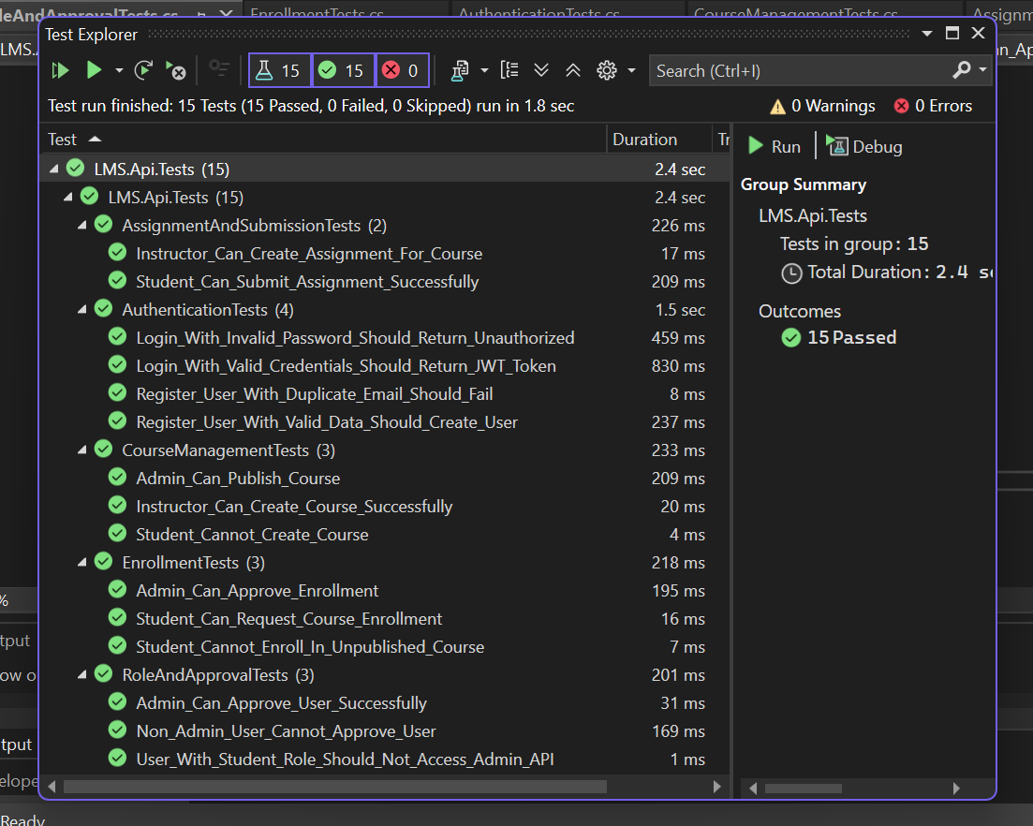

All 15 Tests Implemented and Passing:

A. Authentication & User Management (4 tests)
- ✅ Register_User_With_Valid_Data_Should_Create_User
- ✅ Register_User_With_Duplicate_Email_Should_Fail
- ✅ Login_With_Valid_Credentials_Should_Return_JWT_Token
- ✅ Login_With_Invalid_Password_Should_Return_Unauthorized
B. Role & Approval (3 tests)
- ✅ User_With_Student_Role_Should_Not_Access_Admin_API
- ✅ Admin_Can_Approve_User_Successfully
- ✅ Non_Admin_User_Cannot_Approve_User
C. Course Management (3 tests)
- ✅ Instructor_Can_Create_Course_Successfully
- ✅ Student_Cannot_Create_Course
- ✅ Admin_Can_Publish_Course
D. Enrollment (3 tests)
- ✅ Student_Can_Request_Course_Enrollment
- ✅ Admin_Can_Approve_Enrollment
- ✅ Student_Cannot_Enroll_In_Unpublished_Course
E. Assignment & Submission (2 tests)
- ✅ Instructor_Can_Create_Assignment_For_Course
- ✅ Student_Can_Submit_Assignment_Successfully

📁 Files Created:
- LMS.Api.Tests/LMS.Api.Tests.csproj - Project file
- LMS.Api.Tests/AuthenticationTests.cs - Tests 1-4
- LMS.Api.Tests/RoleAndApprovalTests.cs - Tests 5-7
- LMS.Api.Tests/CourseManagementTests.cs - Tests 8-10
- LMS.Api.Tests/EnrollmentTests.cs - Tests 11-13
- LMS.Api.Tests/AssignmentAndSubmissionTests.cs - Tests 14-15

🔧 Technologies Used:
- xUnit (v2.9.3) - Testing framework
- Moq (v4.20.72) - Mocking
- FluentAssertions (v6.12.1) - Readable assertions
- Microsoft.AspNetCore.Mvc.Testing - Controller testing
- Microsoft.EntityFrameworkCore.InMemory - In-memory DB

Dependencies Used (NuGet Packet Manager LMS.Api.Tests)
